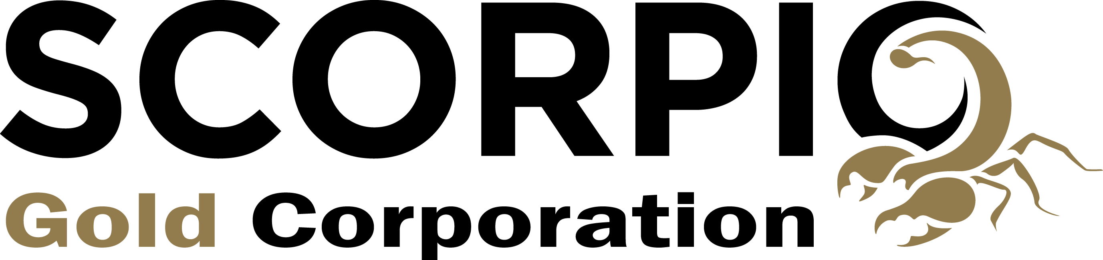 | TSXV:SGN  c/o Suite 910 – 800 West Pender Street,  Vancouver, BC V6C 2V6  www.scorpiogold.com  News Release No. 336

Scorpio Gold Announces Letter of Intent to Acquire Altus Gold
Vancouver, May 25, 2023 – Scorpio Gold Corporation (“Scorpio Gold” or the “Company”) (TSX-V: SGN) is pleased to announce that it has entered into a binding letter of intent dated May 18, 2023 (the “LOI”) setting out the terms of a proposed arm’s length acquisition (the “Transaction”) by the Company of all of the issued and outstanding shares of Altus Gold Corp. (“Altus Gold”), a private mining issuer with two mineral exploration projects in Esmeralda County, Nevada referred to as the Northstar property (the “Northstar Project”) and the historic Vanderbilt exploration project (“Vanderbilt Project”), both adjacent to Scorpio Gold’s Mineral Ridge Mine (“Mineral Ridge”). If completed, the Transaction would consolidate the entire 12-mile ridge, resulting in total land package of 10,652 ha of mineral rights, and 931 ha of surface rights in the prolific Walker Lane mineral district.
“We are very excited to become involved in an advanced gold mining and exploration company in the world’s number one mining jurisdiction for mining, as recently surveyed by the Fraser Institute (1). Scorpio’s two strategic projects, both of which are past producing mines, have near-term production potential with robust economics in the context of the current gold price, alongside their considerable exploration upside”, said Michael Townsend, CEO of Altus Gold.

“This acquisition will provide Scorpio the vehicle to consolidate the known Mineral Ridge exploration potential with the addition of the Northstar and Vanderbilt areas which could ultimately add additional resources to the Mineral Ridge portfolio. The acquisition will also provide the Company the opportunity to realign its management structure to best utilize its officers’ talents for the future growth of the Company. I welcome Michael Townsend and the Altus team to Scorpio and look forward to working with them to provide additional growth opportunities for Scorpio Gold in the future”, said Chris Zerga, CEO of Scorpio Gold.
Terms of Acquisition
Under the terms of the LOI, Scorpio Gold proposes to acquire all the outstanding shares of Altus Gold in exchange for issuing to the shareholders of Altus Gold 16,900,000 post-consolidated Scorpio Gold common shares, having an aggregate deemed value of $3,802,500, based on a deemed value of $0.225 per post-consolidated Scorpio Gold share. Immediately prior to the completion of the Transaction, Scorpio Gold will complete a 5:1 share consolidation, resulting in a total of 59,082,800 Scorpio common shares outstanding following the Transaction, but prior to the Concurrent Financing (as defined herein). The LOI also contemplates that, upon completion of the Transaction, the board of Scorpio Gold will be restructured to include up to three Altus Gold nominees and Michael Townsend, current CEO of Altus Gold, will be appointed Interim CEO of the combined entity, while Chris Zerga will become the Company’s COO. The Definitive Agreement (defined herein) may contemplate payment of finder’s fees to be paid in connection with the Transaction.

Concurrent Financing, Bridge Loan and Financial Information
Pursuant to the LOI, as a condition of closing of the Transaction, the Company will complete a concurrent financing of a minimum of CDN$5,000,000 (the “Concurrent Financing”). Altus Gold has agreed to provide a non-interest bearing, secured bridge loan of $500,000 to Scorpio Gold (the “Bridge Loan”), which will be forgiven upon closing of the Transaction. If the Transaction does not complete for any reason other than a breach by Altus Gold of an enforceable provision of the LOI or the Definitive Agreement, the Loan will be repayable on demand in accordance with its terms.
The following chart sets out selected financial information for Altus Gold:
 | As at and for the year ended August 31, 2022  (unaudited) | As at and for the three months ended November 30, 2022  (unaudited)
Assets | $53,578 | $77,299
Liabilities | $26,203 | $26,254
Revenues | nil | nil
Net Profits | ($2,013) | ($1,330)
The LOI provides that it will, prior to closing of the transaction, be superseded, and replaced with a binding definitive agreement (the “Definitive Agreement”) to be agreed to between the Company and Altus Gold. The Transaction is expected to constitute a reviewable acquisition, as defined under Policy 5.3 Acquisitions and Dispositions of Non-Cash Assets of the TSX Venture Exchange (the “Exchange”) and, accordingly, completion of the Transaction is subject to the approval of the Exchange.
ON BEHALF OF THE BOARD SCORPIO GOLD CORPORATION

Chris Zerga, President

Scorpio Website
Scorpio Investor Deck
Altus Gold Investor Deck

Scorpio Gold Contact
Chris Zerga, President
Tel: (819) 825-7618
Email: czerga@scorpiogold.com

Altus Gold Contact
Zayn Kalyan, Director
Tel: (778) 938-3367
Email: zayn@altuscapital.ca

- https://www.globenewswire.com/en/news-release/2023/05/04/2661158/0/en/Fraser-Institute-News-Release-Nevada-tops-global-mining-survey-rankings-Zimbabwe-again-ranks-last.html

Neither TSX Venture Exchange nor its Regulation Services Provider (as that term is defined in the policies of the TSX Venture Exchange) accepts responsibility for the adequacy or accuracy of this release.
The Company relies on litigation protection for forward-looking statements. This news release contains forward-looking statements that are based on the Company’s current expectations and estimates. Forward-looking statements are frequently characterized by words such as “plan”, “expect”, “project”, “intend”, “believe”, “anticipate”, “estimate”, “suggest”, “indicate” and other similar words or statements that certain events or conditions “may” or “will” occur, and include, without limitation, statements regarding the Transaction and the Concurrent Financing, including the definitive terms and anticipated completion thereof; and the impact of the Transaction on the Company’s portfolio and management structure. Such forward-looking statements involve known and unknown risks, uncertainties and other factors that could cause actual events or results to differ materially from estimated or anticipated events or results implied or expressed in such forward-looking statements, including the anticipated changes in senior management of the Company and those risk factors outlined in the Company’s Management Discussion and Analysis as filed on SEDAR. Any forward-looking statement speaks only as of the date on which it is made and, except as may be required by applicable securities laws, the Company disclaims any intent or obligation to update any forward-looking statement, whether as a result of new information, future events or results or otherwise. Forward-looking statements are not guarantees of future performance and accordingly undue reliance should not be put on such statements due to the inherent uncertainty thereof.

